Unit 5 Dinner’s ready

教材分析 | 本单元学习的主题是用餐。教学内容主要是围绕着用餐的各种情景来展开的。教学重点是能够听、说、认读核心句型“What’s for dinner?”“—What would you like (for…)? —I’d like some…, please.”“—Would you like…? —Yes, please./No, thanks. I can use…”；能够听、说、认读单词“beef, chicken, noodles, soup, vegetable, chopsticks, bowl, fork, knife, spoon”。
教学内容 | 知识与能力目标:  句型  - 听、说、认读句型“What’s for dinner?”“—What would you like (for…)? —I’d like some…, please.”“—Would you like…? —No, thanks. I can use…”  ·在情景中运用句型“—What would you like (for…)? —I’d like…”征求并表达用餐意愿  ·在情景中运用句型“Help yourself.”“—Would you like…? —Yes, please./No, thanks. I can use…”提出用餐建议和餐具使用建议,并恰当回应  ·在情景中运用句型“What’s for dinner?”询问用餐的食物  ·按意群朗读“—What would you like for dinner, John? —I’d like some beef, please.”等三组句子  词汇  ·听、说、认读单词“beef, chicken, noodles, soup, vegetable, chopsticks, bowl, fork, knife, spoon”  ·正确使用上述单词表达用餐意愿和餐具使用情况  ·在有意义的语境中抄写上述话题词汇  语音  ·掌握-e的发音规则,即-e在单词中发长音/ i: /  ·读出符合-e发音规则的单词，并根据发音拼写出符合-e发音规则的单词
课时安排 | 第一课时: Part A Let’s talk & Let’s survey  第二课时: Part A Let’s learn & Let’s play  第三课时: Part A Let’s spell  第四课时: Part B Let’s talk & Let’s play  第五课时: Part B Let’s learn & Let’s do  第六课时: Part B Read and write & Let’s check & Let’s sing

The first period（第一课时）
Part A Let’s talk & Let’s survey
▶教学内容
Let’s talk | ·理解对话大意  ·用正确的语音、语调朗读对话  ·在情景中运用句型“—What would you like (for…)? —I’d like (I would like) some…, please.”征求并表达用餐意愿  ·在情景中恰当运用功能句“What’s for dinner?”  ·在语境中理解新词“dinner, soup, vegetable, ready”的意思,并正确发音
Let’s survey | ·在采访活动中进一步巩固和运用征求用餐意愿及表达用餐意愿的句型,并进一步巩固和运用食物类词汇

▶教学重点
1.能够听懂、会说句型“—What would you like (for…)? —I’d like (I would like) some…, please.”“What’s for dinner?”。
2.能够听懂、会读单词“dinner, soup, vegetable, ready”。
3.能够听懂、会读对话，并能够分角色表演。
▶教学难点
能够在情景中正确使用句型“—What would you like （for…）? —I’d like (I would like) some…, please.”来征求并表达用餐意愿。
▶教学准备
1.PPT课件、食物及饮品图片、价格标签等。
▶教学过程

Step 1: Warm-up & Revision
1. Greetings.
Teaching purpose^{①}
通过这两个活动，让学生在轻松愉快的氛围中复习已学过的食物及饮品单词。同时，游戏活动引入用餐话题，自然地创设真实、有效的教学情景。
2. Sing a song—Let’s have a picnic today. (课件出示: PEP三上教材P54的歌曲动画)
3. Revision.^{①}
(1)Sharp eyes.
Show the words about food and drinks one by one. (课件出示:egg, juice, bread, milk, water, fish, rice, cake依次快速出现，再消失)
T: If you know the word, you can stand up and read it aloud.
(2)Drive a train.
Show the words above and review the word “fish” with pictures. (课件出示:1. 已学的食物及饮品单词egg, juice, bread, milk, water, fish, rice, cake。2. 出示三张图片，图片一:一盘鱼肉，教学fish；图片二:两条同一种类的鱼，教学fish；图片三:两条不同种类的鱼，教学fishes)Let students work in groups of six. Ask every student in the group to ask and answer questions in turn. Make a model:
T: Oh, I’m hungry. I’d like some bread and milk. What would you like?
S1: I’d like some… What would you like?
S2: I’d like some… What would you like?
S3: …
Step 2: Presentation
1. Talk about dinner.^{②}
Teaching purpose^{②}
设置情景，让学生在情景中学习新单词，感知新句型。
(1)Show a picture on the PPT. (课件出示: 一幅图，画面显示太阳落山了，钟表显示18:00)
T: Look! It’s 6:00 in the evening. It’s time for dinner. Guess what “dinner” means.
Ss: 晚餐。
T: Yes. I’m hungry. What’s for dinner? (Show the word card.) Dinner, dinner, /d/-/ɪ/-/n/-/ə (r)/, /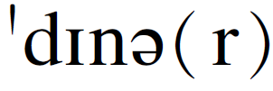/.
Write down the sentence “What’s for dinner?” on the blackboard and teach it.
(2)Show a picture on the PPT. (课件出示: 一张餐桌，学生每提问一次“What’s for dinner?”，餐桌上就出现一种食物，依次为fish, rice, egg, soup, vegetable)
Ss: What’s for dinner?
T: Some fish/rice/eggs.
Ss: What’s for dinner?
T: Some soup. (Show the word card.) Soup, soup, /s/-/u:/-/p/, /su:p/, some soup.
Write down the word “soup” on the blackboard and teach it.
Ss: What’s for dinner?
T: Some vegetables. (Show the word card.) Vegetable, vegetable, /vedʒ/-/tə/-/bl/, //, some vegetables. Pay attention to the pronunciations of “v/v/” and “s/z/”.
Write down the word “vegetable” on the blackboard and teach it.
Show the picture of the table with the food mentioned above. (课件出示:摆放着上述食物的餐桌图片)
T: Oh! Dinner’s ready! I can eat now. (Show the word card.) Ready, ready, /r/-/e/-/d/-/i/, //. Dinner’s ready!
Write down the sentence “Dinner’s ready!” on the blackboard and teach it.
T: What would you like for dinner?
Write down the sentence “What would you like for dinner?” on the blackboard and teach it.
S1: I’d like some…
Write down the sentence “I’d like some…” on the blackboard. Lead more students to answer the question “What would you like for dinner?” by using this sentence structure.
Teaching purpose^{③}
通过各项活动，使学生能够充分理解课文内容，并且能够正确朗读课文。在不同形式的读和表演活动中，使学生逐步理解并掌握本课的重点句型，为其达到熟练表达奠定基础。
2. Let’s talk.^{③}
(1)Talk about Picture 3 of “Let’s talk” and predict the main idea of the dialogue. (课件出示:教材P48 Let’s talk板块的图三)
T: (Point to the picture.) Wow, a lot of delicious food! Dinner’s ready! What’s for dinner?
Ss: Some soup, some bread, some fish and some vegetables.
T: Look at the food. I’m hungry. I’d like some bread. Are you hungry? What would you like?
S1: Yes. I’m hungry. I’d like some…
S2: …
T: Mike is hungry, too. What would he like?
(2)Watch the video and answer the questions.
Show Picture 1 of “Let’s talk”. (课件出示:教材P48 Let’s talk板块的图一)
T: Where are Mike and his mother?
Ss: They are in the kitchen.
T: Mike is hungry. What would Mike like for dinner? Let’s watch the video. Underline the key sentence of the answer in your books.
Play the video and let students get the key sentence. (课件出示:教材P48 Let’s talk板块的音频)
T: What would Mike like?
Ss: Some soup and bread. Mike says, “I’d like some soup and bread, please.”
Teaching purpose^{④}
教师播放录音，学生听录音跟读。引导学生按正确的语音、语调及意群朗读对话，并能够进行角色扮演。
T: What would Mike’s dad like for dinner? Let’s watch the video again. Underline the key sentence of the answer in your books.
Play the video again and let students get the key sentence. (出示课件)
T: What would Mike’s dad like?
Ss: Some fish and vegetables. Mike’s dad says, “Some fish and vegetables, please.”
(3)Read after the video.^{④}
T: Boys and girls, let’s read the dialogue after the video. Please listen to it and read carefully.
Play the video again and ask students to read after it and try to imitate the pronunciation and the intonation. Then let students read together and read freely.
(4)Read the dialogue in different roles. Then act out the dialogue.
T: Now we’ll find the best actor or actress. Please come to the front and show the dialogue.
Take out some headdresses and ask some students to act out the dialogue.
(5)Retell the dialogue according to the blackboard-writing and the pictures of “Let’s talk”.
Make a model first and then lead students to retell the dialogue without their textbooks.
Teaching purpose^{⑤}
通过完成调查活动，进一步巩固练习新单词及核心句型，在创设的语境中提高学生的语言运用能力，使学生能够熟练运用所学语言询问及表达用餐意愿。
Step 3: Practice^{⑤}
Let’s survey.
(课件出示:教材P48 Let’s survey板块的表格及以下句型)
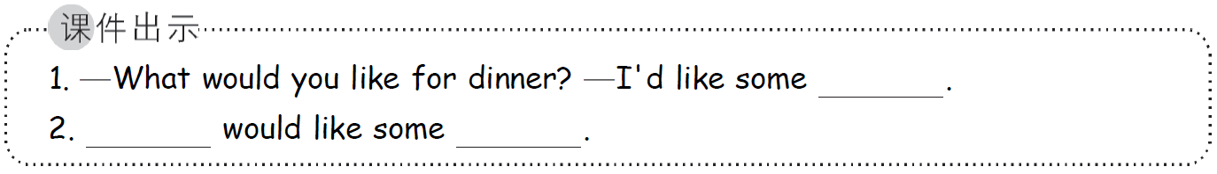
T: Suppose it’s time for dinner. What would you like for dinner? Let’s make a survey.
Let students do the survey in groups of four.
Make a model:
T: S1, what would you like for dinner?
S1: I’d like some fish and rice.
T: S2, what would you like for dinner?
S2: I’d like some bread and milk.
T: …
S3: …
T: S1 would like some fish and rice. S2 would like some bread and milk. S3…
Teaching purpose^{⑥}
教师让学生先模仿练习对话，再创设在餐厅点餐的情景，层层深入，为学生创建真实的语言运用环境，以此巩固本节课的重点内容,同时达到学以致用的目的。
Ask each group to choose a reporter to interview the other three students, fill in a form and report the results to the whole class.

Step 4: Consolidation & Extension^{⑥}
1. Make a new dialogue.
Ask students to imitate the text to make a new dialogue.
(1)Make a model.
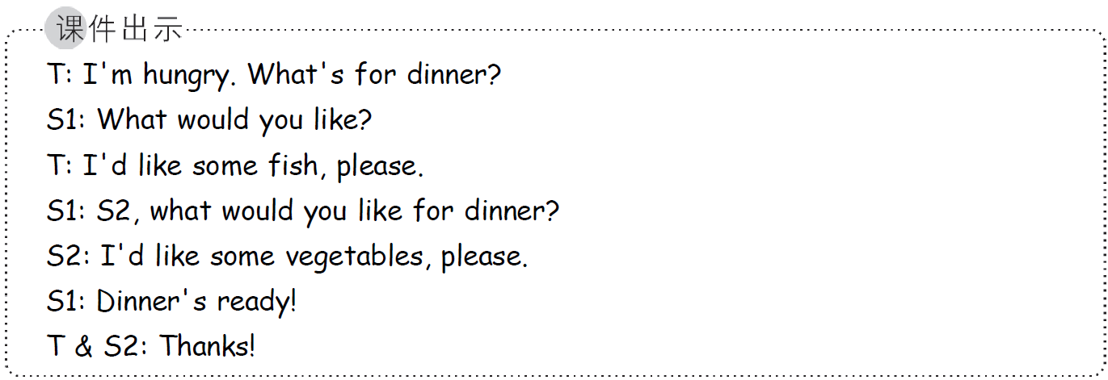
(2)Let students imitate to work in groups of three. Then make a new dialogue in groups.
(3)Show time.
Ask some groups to act out their dialogues.
2. In the restaurant.
(课件出示:一家餐厅的背景和句子“Don’t waste food.”)
Take out a prepared chef cap, some pictures of food and drinks and the relevant price tags. Let students act as customers or a cook.
(1)Make a model.
T: Look! What do I do? Yes, I’m a cook. I can cook delicious food. Please come to my restaurant for dinner. My restaurant’s rule is “Order as much as you can eat. Don’t waste food.”
T: Welcome to my restaurant! What would you like for dinner?
S1: I’d like…
T: Here you are. Ten yuan, please.
S1: Thank you!
(2)Let students work in groups.
(3)Show time.
Ask some groups to act out.

▶板书设计
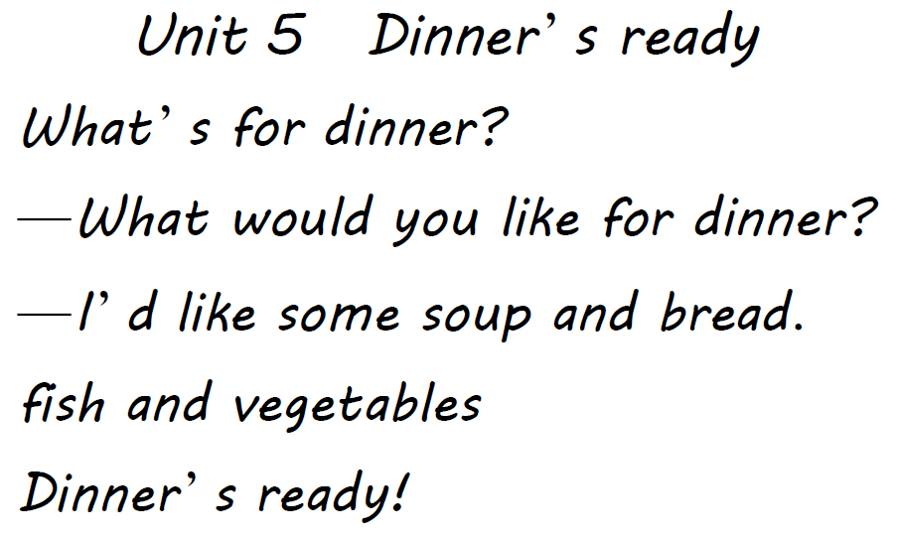

▶作业设计
1. Read the dialogue of “Let’s talk” five times.
2. Ask your parents with the key sentence structures and write their answers down.

